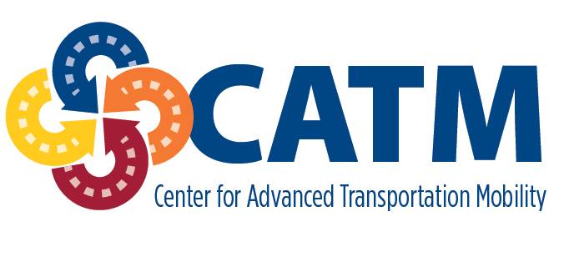

The Transportation Institute at North Carolina A&T State University

Center for Advanced Transportation Mobility (CATM)

Transportation Scholars Award Application

APPLICATION MUST BE TYPED

ALL APPLICATIONS MUST BE IN THE TRANSPORTATION INSTITUTE NO LATER THAN APRIL 3, 2020.

The CATM Transportation Scholars Award Program is open to transportation/supply chain majors who are interested in participating in experiential learning and extra-curricular activities and events provided through the Transportation Institute. Award recipients will receive between $1,000 and $5,000 based on their GPA and engagement in transportation/supply chain activities.

NAME: | BANNER # :
TELEPHONE: ( ) - | E-MAIL:

PERMANENT HOME ADDRESS:

TELEPHONE: ( ) -

MAJOR:

CURRENT CLASSIFICATION: | EXPECTED DATE OF GRADUATION: / /
CUMULATIVE GPA: . | CURRENT GPA: .

DESCRIBE YOUR TRANSPORTATION INTERNSHIP AND/OR TRANSPORTATION WORK EXPERIENCE(S)
(ATTACH ADDITIONAL SHEET IF NECESSARY)
SUPERVISOR/MENTOR:
LOCATION:
RESPONSIBILITIES/ACTIVITIES:

WHY SHOULD YOU BE SELECTED TO RECEIVE THE CATM TRANSPORTATION SCHOLARS AWARD?

Include additional transportation-related activities that you have participated in or skills you have developed over the course of your academic career. List transportation and supply chain organizations in which you have been active; include offices held, awards/honors received, etc.

If I am selected to receive the CATM Transportation Scholars Award, my signature below indicates my commitment to participate in and attend the requisite number of transportation-related experiential learning and extra-curricular activities and events provided through CATM and the Transportation Institute.

SIGNATURE DATE ____________________________

