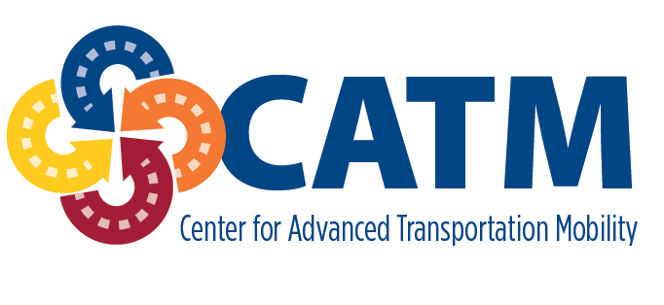
Vulnerable Road User Mobility Assistance Platform (VRU-MAP)

Final Report

December 2022

AUTHORS

Justin M. Owens

Virginia Tech Transportation Institute

Andrew Miller

Virginia Tech Transportation Institute

US Department of Transportation Grant 69A3551747125

DISCLAIMER

The contents of this report reflect the views of the authors,
who are responsible for the facts and the accuracy of the
information presented herein. This document is disseminated
under the sponsorship of the Department of Transportation,
University Transportation Centers Program, in the interest of
information exchange. The U.S. Government assumes no
liability for the contents or use thereof.

- Report No. |  | - Government Accession No. |  |  | - Recipient’s Catalog No.
- Title and Subtitle  Vulnerable Road User Mobility Assistance Platform (VRU-MAP) |  |  |  |  | Report Date  December 2022
 |  |  |  |  | - Source Organization Code
- Author(s)  Owens, Justin M.; Miller, Andrew |  |  |  |  | - Source Organization Report No.  CATM-2023-R1-VTTI
- Performing Organization Name and Address |  |  |  |  | - Work Unit No. (TRAIS)
Center for Advanced Transportation Mobility  Transportation Institute  1601 E. Market Street  Greensboro, NC 27411 |  |  |  |  | - Contract or Grant No.  69A3551747125
- Sponsoring Agency Name and Address  University Transportation Centers Program (RDT-30)  Office of the Secretary of Transportation–Research  U.S. Department of Transportation  1200 New Jersey Avenue, SE  Washington, DC 20590-0001 |  |  |  |  | - Type of Report and Period Covered  Final Report: February 2018 – December 2022
- Sponsoring Agency Code
USDOT/OST-R/CATM
- Supplementary Notes:
- Abstract
This report documents the development of a prototype Vulnerable Road User Mobility Assistance Platform (VRU-MAP), a novel effort to conceptualize and develop a navigation solution directed toward the needs of people with disabilities (PWD). PWD represent about 15% of the world’s population and disproportionately face barriers to transportation, which represents a critical component to daily life, relative to people without disabilities. One barrier to transportation is the lack of dedicated walking navigation solutions. While smartphones and other GPS implementations have made walking directions from location to location nearly universally obtainable, these tools generally do not provide routing that takes into account an individual user’s capabilities and needs. This VRU-MAP application, which is currently implemented in a functional prototype, uses novel coding based on combining existing open-source maps (OpenStreetMap), publicly available environmental information (e.g., weather, elevation, etc.) and crowd-sourced hazard information with a user’s self-reported personal capabilities and needs. This combination of persistent and real-time information allows for the generation of personalized navigation directions, which are then presented in a turn-by-turn manner to users. Real-world testing demonstrated substantial promise in the functional prototype, while at the same time illustrating areas for future improvement and refinement including expanding capabilities, improving interface design, and improving routing component integration. Next steps include identifying additional partners to develop the prototype into a deployable application, including partnering with disability experts to ensure that final design and implementation are both useful and acceptable to the broadest possible range of users, including integrating with and being accessible by current assistive technologies such as screen readers.
- Key Words  Disability, Mobility, Transportation, Equity, Travel |  |  | - Distribution Statement  Unrestricted; Document is available to the public through the National Technical Information Service; Springfield, VT.
- Security Classif. (of this report)  Unclassified | - Security Classif. (of this page)  Unclassified |  |  | - No. of Pages  #32 |  | - Price  …
Form DOT F 1700.7 (8-72) Reproduction of completed page authorized

TABLE OF CONTENTS

TABLE OF CONTENTS i
EXECUTIVE SUMMARY 1
DESCRIPTION OF PROBLEM 2
Navigation Challenges Faced by People with Disabilities 2
Challenges Facing Pedestrian Mobility 3
Persistent Path Barriers 4
Temporary Path Barriers 5
Project Goal 7
APPROACH AND METHODOLOGY 9
Conceptualization 9
Back-end Operations 10
Firebase 10
Postgres & PostgREST 10
Mapbox 11
Functionality 11
Implementation 11
Initial Setup/Login Page 11
Personalization Page 12
Navigation Initiation Page 13
Turn-by-Turn Navigation Page 14
Hazard/Site Description Pop-up 15
Testing and Analyses 17
FINDINGS, CONCLUSIONS, RECOMMENDATIONS 20
Findings 20
Next Steps 22
General Conclusions 22
REFERENCES 23
Appendix A: Sample Segment Edgeweight Matrix and User Questions 24
Appendix B: Presentations & Posters Resulting from this Project 27

EXECUTIVE SUMMARY
This report documents the development of a prototype Vulnerable Road User Mobility Assistance Platform (VRU-MAP), a novel effort to conceptualize and develop a navigation solution directed toward the needs of people with disabilities (PWD). PWD represent about 15% of the world’s population and disproportionately face barriers to transportation, which represents a critical component to daily life, relative to people without disabilities. One barrier to transportation is the lack of dedicated walking navigation solutions. While smartphones and other GPS implementations have made walking directions from location to location nearly universally obtainable, these generally do not provide routing that takes into account an individual user’s capabilities and needs.
In this project, the team built upon previous work (e.g., Owens, Miller, and Shivers, 2019) to identify the most pressing transportation and navigation-related needs for people with a wide range of disabilities, and used these as a foundation to conceptualize a next-generation pedestrian navigation application that integrates personal capabilities, needs, and limitations with external information to provide real-time, personalized routing.
This VRU-MAP application, which is currently implemented in a functional prototype, uses novel coding based on combining existing open-source maps (OpenStreetMap), publicly available environmental information (e.g., weather, elevation, etc.) and crowd-sourced hazard information with a user’s self-reported personal capabilities and needs. This combination of persistent and real-time information allows for the generation of personalized navigation directions, which are then presented in a turn-by-turn manner to users.
Real-world testing demonstrated substantial promise in the functional prototype, while at the same time illustrating areas for future improvement and refinement including expanding capabilities, improving interface design, and improving routing component integration. Next steps include identifying additional partners to develop the prototype into a deployable application, including partnering with disability experts to ensure that final design and implementation are both useful and acceptable to the broadest possible range of users, including integrating with and being accessible by current assistive technologies such as screen readers.

DESCRIPTION OF PROBLEM

Navigation Challenges Faced by People with Disabilities
People with disabilities (PWD) represent approximately 15% of the world’s population but face a broad array of well-documented challenges in daily life compared to people without disabilities. These range from intentional and unintentional discrimination to related economic factors, including underemployment and lower average income than people without disabilities, which are in turn exacerbated by challenges in education and transportation. Since transportation is often an instrumental activity of daily living and may be fundamental to a person’s quality of life, it is critical to address transportation-related mobility challenges that can make daily and intermittent travel challenging or even impossible.
As previous work has discussed (e.g., Owens, Miller, & Shivers, 2020), the term “PWD” encompasses individuals with a broad range of disabilities and lived experience who face substantial and varied challenges in physical, perceptual, and/or cognitive domains, depending upon the type(s) of disability. These challenges are generally not limited to one aspect of daily life, but instead are pervasive across all activities. Mobility issues can be particularly impairing, as people with mobility limitations must often navigate unaccommodating or hostile surroundings to successfully reach their destination. People without access to appropriate accessibility-equipped vehicles face a unique set of difficulties when traveling, whether as pedestrians, transit-users, or when utilizing multi-modal travel. For pedestrian travel, these challenges may include physical impediments like a lack of curb cuts for wheelchair users, perceptual barriers such as a lack of audible signals for the visually impaired, and confusing or overwhelming environments for people with cognitive or learning disabilities. For transit users, these may include physical inaccessible transit vehicles and hubs, inaccessible schedule information, and complex operation instructions.
Many of these challenges, particularly those related to physical infrastructure and transit, ideally would be addressed by changes to infrastructure, which may be encouraged or mandated by law (e.g., the Americans with Disabilities Act [ADA]). Developmental techniques, including Universal Design (e.g., Steinfeld & Maisel, 2012), can be used to support the implementation of solutions that can benefit broad categories of users. Curb cuts are good examples of this, as they are helpful for users beyond PWD, including the non-disabled elderly and people pushing strollers. However, there is need for more immediate solutions that do not rely on systemic change. Further, while many existing and nascent solutions address individual needs, such as curb cuts or audible crossing signals in many locations, they do not represent one-size-fits-all solutions to the broad variety of needs and challenges facing the spectrum of PWD.
Because of the complexity PWD face when navigating the built environment, the goal of this project was to conceptualize and develop a prototype navigation system to provide tailored mobility solutions across a range of user needs and environmental situations.

Challenges Facing Pedestrian Mobility
In today’s world, pedestrians often navigate unfamiliar areas using smartphone or tablet GPS applications such as the one pictured in Figure 1. In most cases, there is only one recommended route, and that route is the same for all users, whether they are able to traverse the path or not. The route itself does not take into account potential barriers for PWD, such as the presence of sidewalks or other walkable areas, ADA-compliance for wheelchairs or mobility scooters across ramps and curbs, appropriate accessibility in construction zones, blind- or hearing- assistive technologies or road designs, among many others.
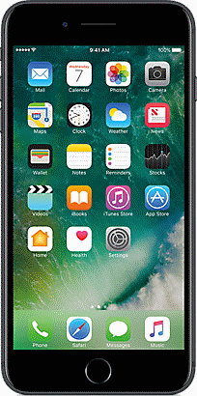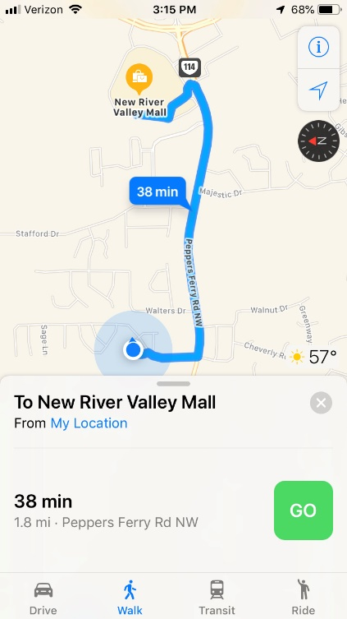
Figure 1. Example pedestrian walking route in a traditional navigation application.
In order to develop a solution to counter mobility barriers, it is necessary to consider the range of challenges and barriers faced by PWD that are not accounted for by traditional navigation apps. While the following is not intended to be an exhaustive list, it will illustrate the types of situations that could pose barriers that may be circumvented by a navigation solution.

Persistent Path Barriers
Many pedestrian routes have persistent barriers such as stairs, missing sidewalks, or damaged sidewalks that impede the ability of pedestrians with disabilities to safely travel. Figure 2 represents such a situation on a university campus, where a major thoroughfare relies on the ability of pedestrians to climb multiple sets of stairs. Stairs may be impassible by people using wheelchairs or personal mobility devices, who use walking aids like walkers, have limited strength, or who are susceptible to imbalance or slipping.
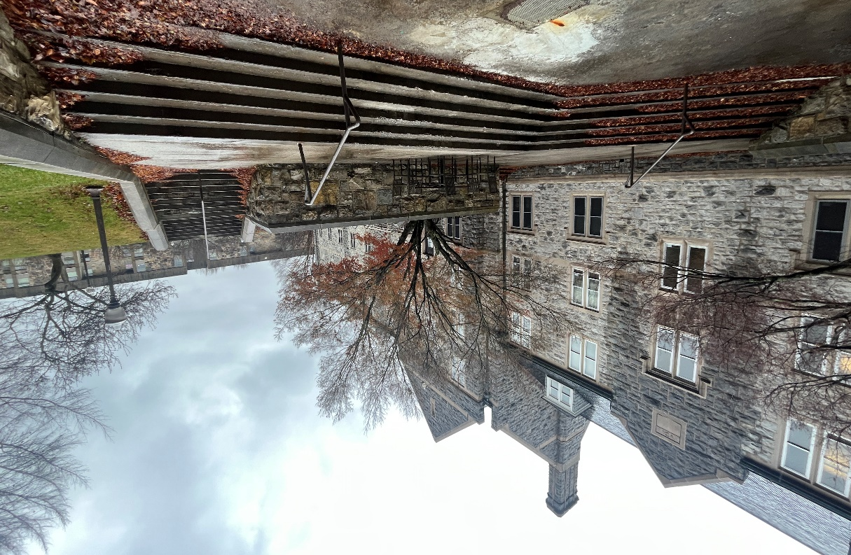
Figure 2. Path requiring stair traversal.
In other cases, even when sidewalks and ramps theoretically facilitate traversal by people with mobility difficulties, these may be impassable due to wear or damage, such as buckling due to tree roots that could block a wheelchair or major cracks that could cause tripping or trap a cane.

Temporary Path Barriers
Unlike stairs, broken sidewalks, and other persistent barriers, some obstructions are temporary and limited in duration. One example of this is when weather such as heavy rain or ice renders a section of sidewalk impassible, an example of which can be seen in Figure 3. In this case, a low area of sidewalk is covered in several inches of water after a heavy rainfall, which could pose a serious impediment to people with mobility or perceptual disabilities. Similarly, ice-covered sections of sidewalk could pose a more severe fall hazard for people using mobility devices or relying on canes.
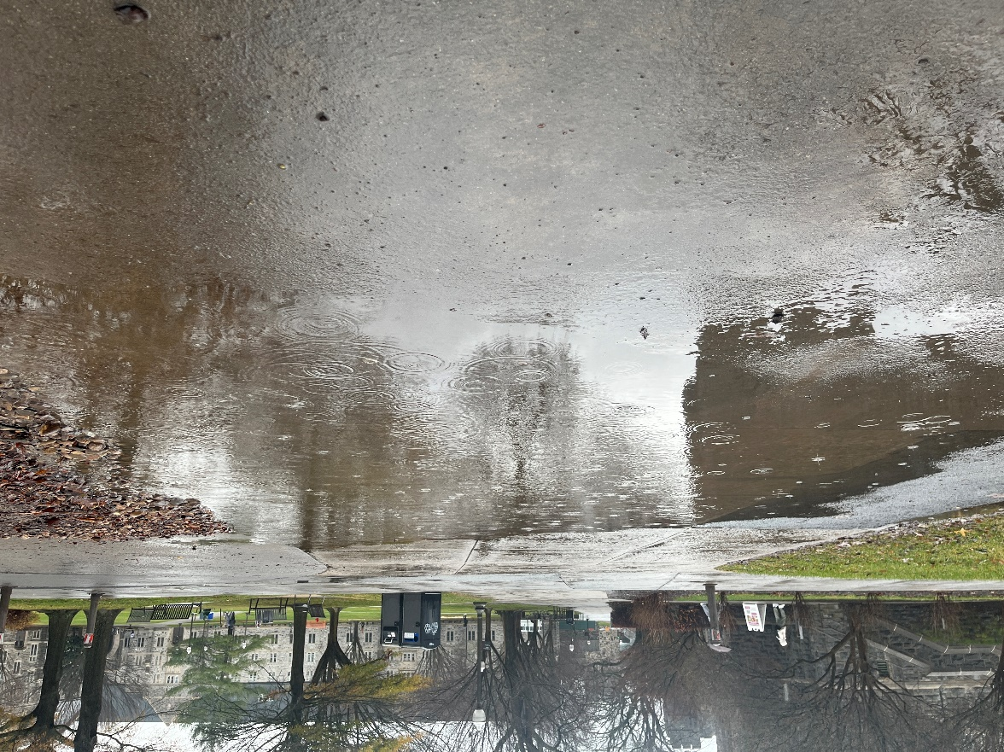
Figure 3. Path blocked by pooled rainwater.
Another example of a temporary path barrier is when a sidewalk is undergoing construction, such as in Figure 4. Here, pedestrians must transition from the sidewalk onto a temporary path that may or may not be facilitated by curb cuts and may have pooled water or other environmental challenges and must be alert for other construction-related hazards, such as sharp edges and drops.
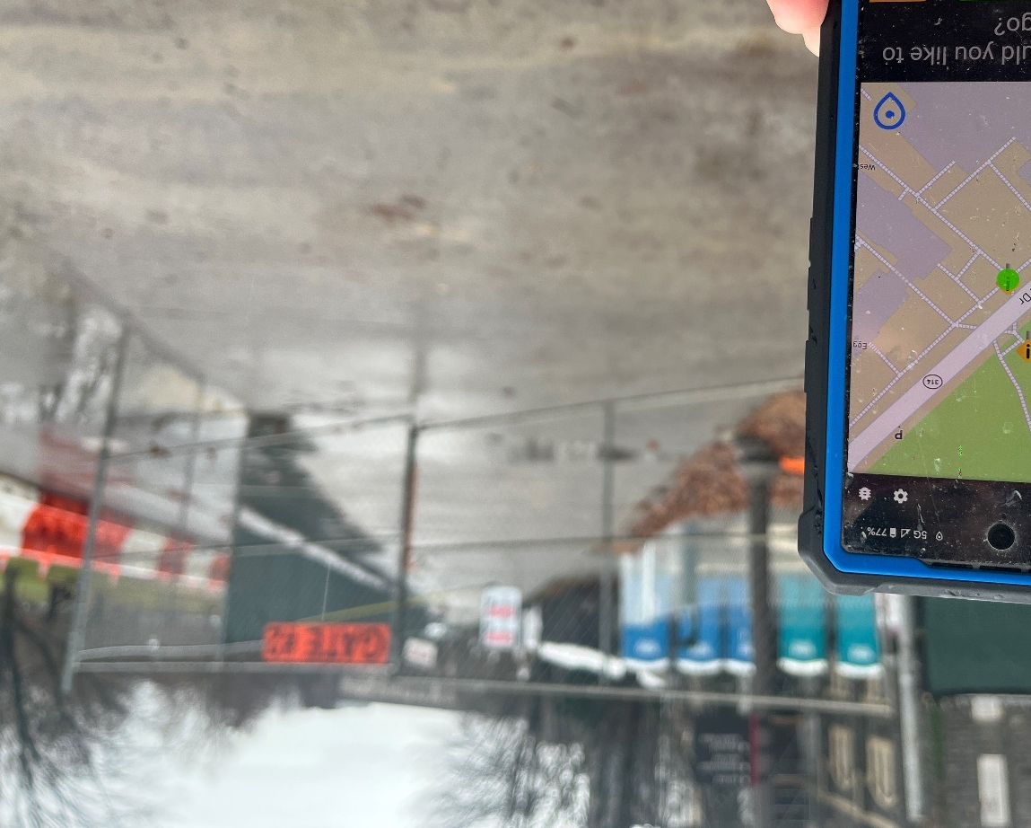
Figure 4. Sidewalk blocked by temporary construction.

Project Goal
Given the example challenges discussed above, this project was conducted to conceptualize and prototype a mobile (smartphone/tablet) application platform to assist people who have physical, perceptual, cognitive, and/or learning disabilities with non-driving navigation of the built environment. At its core, recognizing that every individual’s capabilities and challenges are unique, the goal of this platform was to combine personal capabilities with external information to result in a flexible, personalized assistance platform.
While the development of a market-ready application was beyond the scope of this project, the team’s goal was to develop a prototype application as a proof-of-concept that could be leveraged for future partnerships and development. Subtasks and project components included the following:
- Develop a series of user and environmental cases for initial focus.
- Conceptualize the theoretical underpinnings supporting a flexible navigation system, incorporating both personal capabilities and external environmental information.
- Design an interface that will be flexible and usable by the target audience.
- Implement this conceptualization in a usable, functional prototype application deployed on a physical device.
- Test the prototype application in public areas to determine areas for future focus and development.
- Prioritize student development and involvement throughout the project.

APPROACH AND METHODOLOGY

Conceptualization
The core development goal for this project was to produce a platform that is highly customizable to allow all users to have an inclusive and personalized mobility solution. The customizable/modifiable aspects of the Vulnerable Road User Mobility Assistance Platform (VRU-MAP) were created to accommodate the varied needs of users with disabilities, as well as users who may not have disabilities but prefer more personalized routing than traditional applications provide. These modifiers were identified based on previous research as being reflective of user needs across numerous physical and mental attributes, including individual capabilities like physical conditions and mental constraints. Primary user considerations throughout the development of the app included physical disabilities that require attention related to ADA-compliant pathways (e.g., curbs with cuts for wheelchair access, ramps) as well as sensory or perception impairments (e.g., visual impairment, hearing impairment). The customizations idealized throughout the VRU-MAP development were implemented in an adaptable format, allowing users to determine which modules are applicable to them. Inherent flexibility in the routing coding supports future expansion to include additional user considerations.
To allow modifiers to influence route development, the team developed a novel routing algorithm that utilizes the concept of modifiable edgeweights. Here, routes are constructed using a series of geographic links – or segments – that are each assigned a weight based on a combination of ratings of factor values and user preference. Potentially impeding factors such as steps and inclines result in negative weights, depending on a user’s pre-set preferences, while potentially supporting factors such as shorter distance and the availability of places to rest result in positive weights (again, given the user’s preferences). As illustrated in the hypothetical edgeweight matrix presented in Appendix A, each factor’s external value is multiplied by an importance factor defined by the user’s settings, resulting in an edgeweight for each segment. For example, a segment with a higher slope will have a lower rating than a segment with a lower slope, for a user who needs to avoid elevation changes. Potential routes are then compared by the sum rating of the combined edgeweights for all links within each route, and the optimal route is selected to present to the user.
Further, to better accommodate all individuals, the user interface (UI) of the application was designed to be flexible and easy to use with the goal of presenting information in a clear and consistent manner. To accomplish this, a one-page home screen was created that allows users to see their location, nearby points of interest, and search for places using customizable “easy-access” buttons. Settings were also designed to be easily accessible, allowing users to adjust account information and other UI elements; however, the goal was to minimize the need to return to these settings. Illustrations of these UI elements are presented in the Implementation section below.

Back-end Operations
Due to the complexity inherent in the integration of multiple data streams for route formulation, several software programs, packages, and data types were utilized throughout the development of the VRU-MAP.

Firebase
Google’s Firebase app development platform (firebase.google.com) was used to store both personal information and crowdsourcing information. Personal information includes user account settings, user restrictions, and other navigation considerations. A user restriction table is stored during account creation and can be changed by users updating profile settings.
A user can add points of interest (POIs; e.g., hazards, resting areas) to the map by using a button on the main page, specifying what the obstacle is, and then placing it on the map. The location of the POI, the title, a description (optional), a picture (optional), and the author (optional) of the reported hazard are all stored in Firebase. These hazards are loaded onto the platform automatically and further displayed on the navigation page after a user requests directions.

Postgres & PostgREST
The Postgres database stores road data, including coordinates of intersections, sidewalks, accessible areas, and road names. The database also has stores functions that draw on road data to create custom routes based on personalized user restrictions. PostgREST acts as a REST application programming interface (API) that allows the user to call functions within the database from VRU-MAP. This provides the communication network between the database and external channels to produce the custom route. The custom route function accepts an origin and destination and responds with a list of coordinates that comprise the calculated route.

Mapbox
Mapbox, an open-source map database and navigation software development kit (www.mapbox.com), is the primary source of mapping tools, including geocoding, displaying maps, displaying routes, map matching (e.g., taking the custom points and displaying them as a VRU-MAP route), and displaying turn-by-turn navigation.

Functionality
Once a user has selected a destination by pressing the “directions” button, a routing screen shows the route, crowdsourced hazards, elevation data along the route, bus locations, walk time, and walk distance. Users can also add hazards to the map via a crowdsourcing portal, represented by a button on the bottom left of the screen, as will be illustrated in the following section.

Implementation
The core development goal of this project was to deploy the application concept in a functional prototype using a physical device—in this case, an Android-based smartphone. As currently deployed, the application contains a series of screens, or view controllers, depicting various program features and reflecting the individualized nature of the platform. Specific interface components include:

Initial Setup/Login Page
Upon first use of the app, users encounter the User Login page (Figure 1). This page requests the user to input their email address or username. This information is stored under a custom created header with the username in a Firebase database.
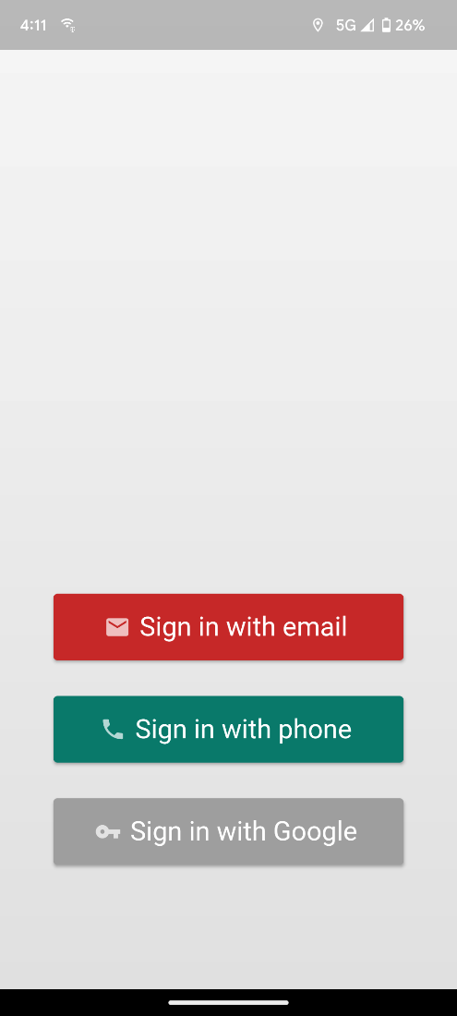
Figure 5. Login page.

Personalization Page
After initial login, the user is redirected to a personalization page (Figure 6), where they can specify their individual needs by answering a series of questions that aim to better identify their navigational constraints and preferences. Examples of potential constraints include walkable distance, maximum slope that can be climbed, need for bathroom accessibility, ability to climb stairs, and need for shelter and rest, among others. The routing algorithm incorporates user constraints and preferences with externally provided environmental information to create a customized route. Future implementations could support this information being stored on-device for privacy and security reasons.
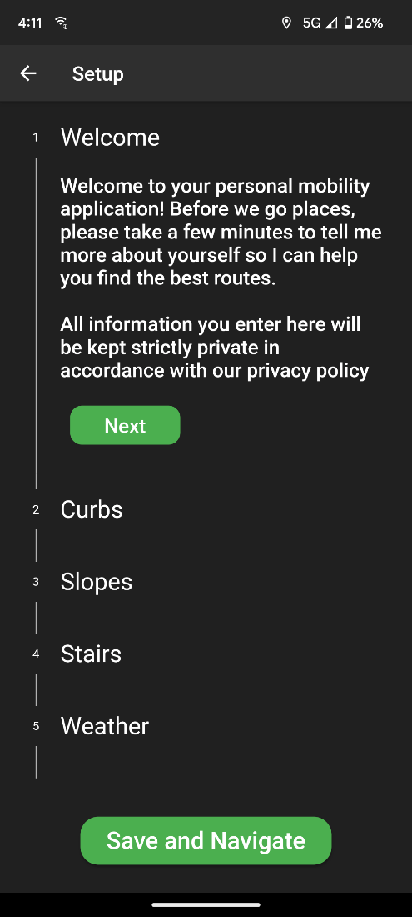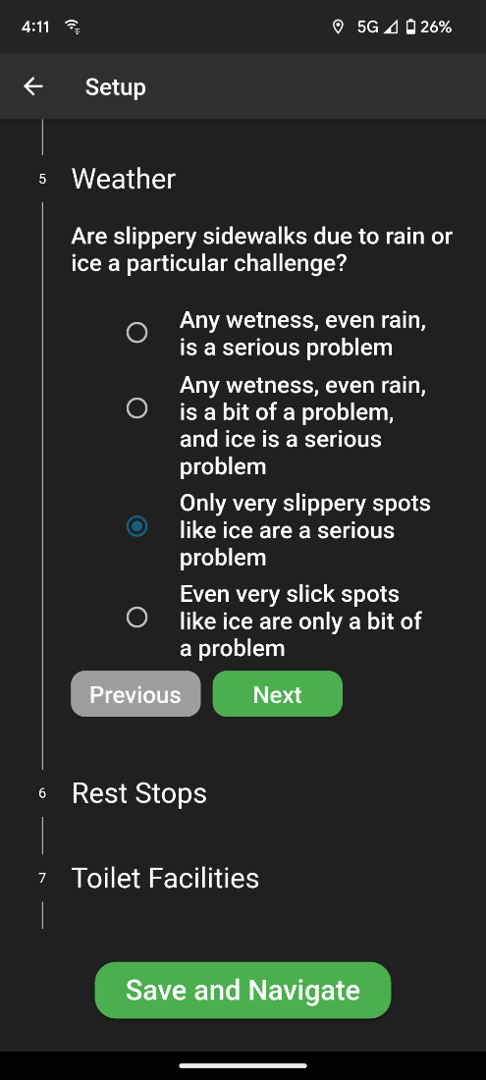
Figure 6. Example personalization pages.

Navigation Initiation Page
The Navigation Initiation page is used to display the user’s starting and requested destination locations. The user’s current location is used as the default starting location; however, users can also access customized start locations. Once the user enters both locations, forward geocoding and POI mapping are used to retrieve the latitudes and longitudes corresponding to these address names. That location data is passed to the next view controller, where the actual route will be plotted. The user will receive a route option and must confirm selection before beginning navigation (Figure 7).
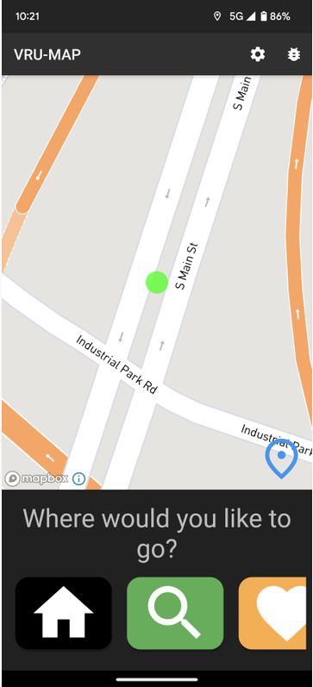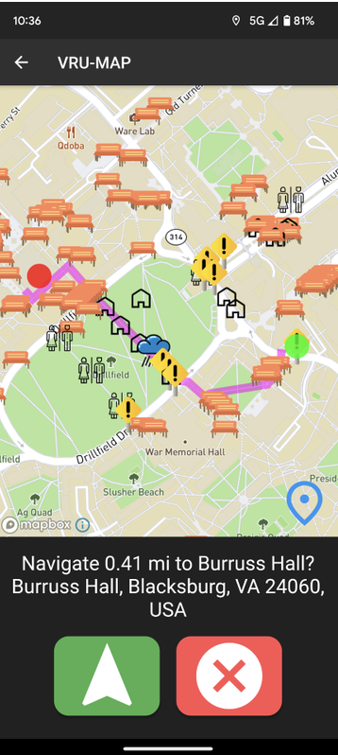
Figure 7. Example navigation initiation pages.

Turn-by-Turn Navigation Page
The Turn-by-Turn Navigation page displays the turn-by-turn customized route selected by the user (Figure 8). A user can cancel the route at any time, as well as add crowdsourced information. This map has a button on the bottom right labeled “Annotate.” Once this button is pressed, the user is provided with the Hazard/Site Description pop-up.
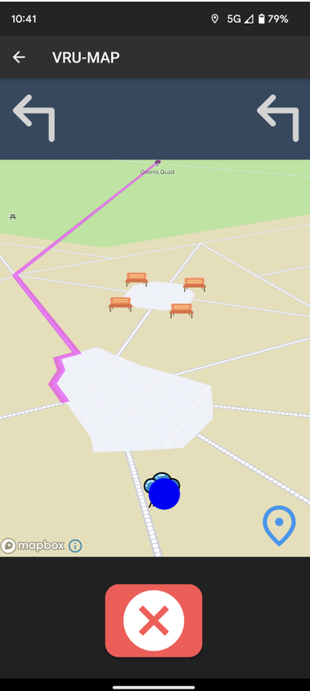
Figure 8. Turn-by-turn view showing simple interface and hazards/rest points.

Hazard/Site Description Pop-up
This page is prompted when the user taps the site annotation icon. A prompt to add a point of interest (POI) is provided (Figure 9), which includes the type of site and the option to write a name and/or description of the icon. There is an “Add POI” button that the user can press once they have filled in all of the information. Once that button is pressed, all information will be saved in the Firebase database under the header name of that user and the user will be redirected back to the map view.
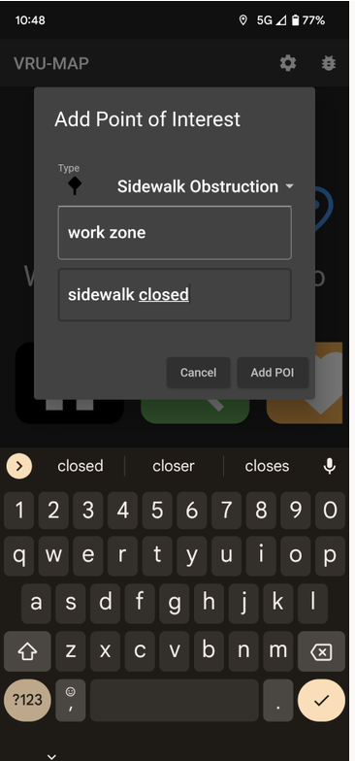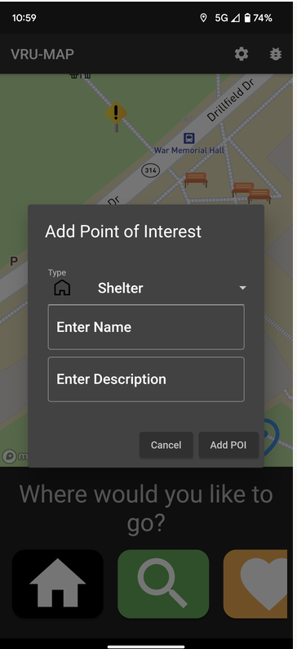
Figure 9. POI input pages.
As it is critical to provide users with information that is both accurate and timely, all crowdsourced hazards receive timestamps upon input. Based on the data the user provides with a hazard, a time limit can be set by the user or built into the system for each hazard type, depending on the anticipated duration of the hazard; for example, an ice patch may be expected to disappear when a day warms above freezing. After the time limit expires, the hazard will be removed from the route. Other users can also identify whether specific hazards still exist or not.

Testing and Analyses
The research team conducted iterative testing of platform functionality over the course of the project to determine progress, necessary adjustments, and next steps, with final testing being conducted on foot in a university town environment (Figure 10).
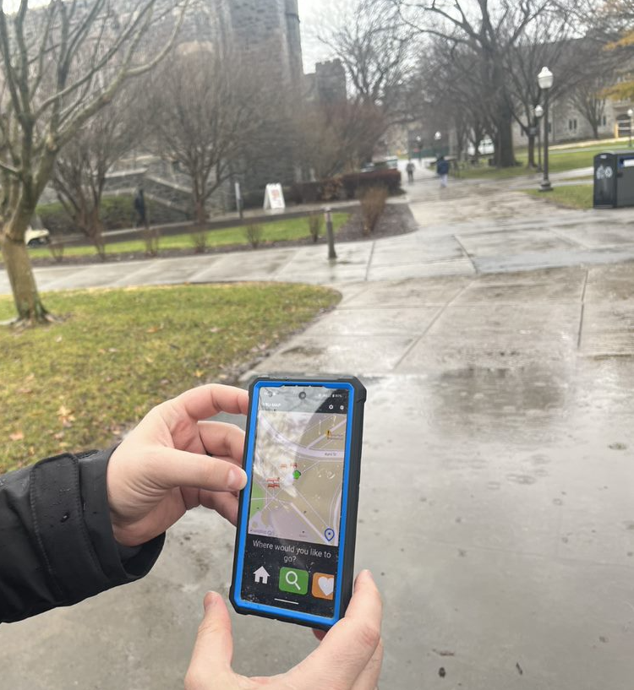
Figure 10. Real-world final application testing.
Both iterative and final testing generally involved the following goals:
- Check overall app functionality and usability.
- Determine navigation route efficacy, including shortest distance accuracy and accuracy of route restrictions.
- Evaluate crowdsourcing capabilities, including icon selection, placement, and transitions.
- Evaluate GPS tracking and step-by-step route navigation.
- Determine accuracy and display of integrated POIs and other sourced information.
In final testing, the app was demonstrated to be functional and to fulfill the core project requirements, as described further in the following section. Testing also revealed a number of areas for further development, which will lay the foundation for future project iterations and collaborations. Existing and potential future features are listed in Table 1.
Table 1. Categorized ideal and prototype on VRU-MAP.
Feature | Category | Description | Ideal Functionality | Prototype Functionality
Custom routes | Routing | Customized routes to minimize distance based on user needs | Full implementation | Partial implementation
Sidewalk-included routing | Routing | Provides pedestrian-friendly routing options for users - includes sidewalk data | National sidewalk data | Local data downloaded with national data accessible
Transit/Paratransit bus routes | Routing | Integration of live-bus feeds into the UI with integration into routing | Integration into UI and routing algorithms | UI Integration
Multimodal routing | Routing | Integration of metro, subway, paratransit, and other modalities into routing algorithms | Full integration | Conceptualized functionality limited by API and accessible data
Options for Predetermined POIs | Crowdsourcing | Utilize a common set of POIs for users to place hazards or helpful remarks based on GPS locations | Full integration | Full integration
Edgeweight routing | Routing | Assignment of edgeweights to personal settings and crowdsourced POIs used to influence the route options provided to the users | Full integration using personal settings and POIs | Preliminary edgeweight values utilizing placed POIs and sample personal settings
Options for Custom POIs | Crowdsourcing | Allows users to put custom POIs on the map to alert other users or make them aware | Full integration | Conceptualized custom options
Time-limited hazards | Crowdsourcing | Built-in or customizable time limits to support temporary hazards like ‘flooded surface’ or ‘icy patch’ | Table of expected time limits integrated into POI placement | No current implementation
Leaderboard | Crowdsourcing | A leaderboard to support the adoption of the platform and to encourage user interaction by scoring utility of placed POIs | Implemented leaderboard | Conceptualized functionality
Other-app integration | Personalization | Provides users with the ability to interact with other phone applications, such as users’ calendar | Functional utilization to combine various app features to increase mobility options | Conceptualized functionality
Augmented reality (AR) implementation | Accessibility | Allows users to enable augmented reality to determine when or where to turn along the routed path | Full implementation for eligible phone types | Limited demonstrations of AR overlay with route across the iPhone using ARCore kits
Auditory commands | Accessibility | Provides users with auditory alerts or commands during navigation for those that have limited vision | Full implementation into routing and user set-up pages | Conceptualized functionality

FINDINGS, CONCLUSIONS, RECOMMENDATIONS

Findings
Laboratory and real-world testing demonstrated that the VRU-MAP application represents a solid proof-of-concept from both design and implementation perspectives, with the potential to provide user-centric navigation assistance for people with a broad range of disabilities. In line with the principles of Universal Design, deployment of this concept could also find value as a pedestrian routing application for non-disabled users, particularly those who value route flexibility and customization.
The strengths of the final application prototype include the following:
- Functional implementation on multiple platforms
Implementation included real-time routing and crowdsourcing and was demonstrated in real-world testing. Because the development of this project was completed in Flutter, source code can be readily deployed on both Android and iOS devices.
- Simple design relative to existing pedestrian navigation applications
Large interface elements support operation by people with a broad range of perceptual and motor capabilities, including people with minor visual and motor control impairments. To support a simple and intuitive interface, frequently used functions are available as shortcuts and/or are accessible from the primary navigation screen. Future iterations of the application should extend this support, including user-modifiable size and contrast in an easily accessible menu, and support for both built-in and third-party screen-reading software and hardware.
- Conceptual integration of multiple data sources
These sources include personal capability data, environmental data from multiple sources, crowdsourced hazard data, transit information, and current position via GPS. Integration was found to be feasible and was implemented in a basic capacity. Future iterations should build upon this, using the concepts and methods implemented here, to fully support a broad range of user needs.
- Routing proof-of-concept
While there remain routing features yet to be implemented, such as incorporation of real-time weather data and tweaking of edgeweight parameters, the basic routing concept was implemented in code running on physical Android-based hardware. A field demonstration showed that the app is capable of routing users to their destinations while guiding them around placed and environmental obstacles.
- Successful incorporation of student development
Throughout the project, the team prioritized student involvement, from project planning to conceptualization to development to presentation. The project enabled seven undergraduate students to contribute meaningfully, with most having the opportunity to present their work in CATM and at other conferences and symposia. A list of presentations may be found in Appendix B.
- Foundation for future collaborations and project expansion
Given the accomplishments above, the results have laid the groundwork for future collaborations and research projects. The team intends to pursue further funding from government sources (e.g., the National Institutes of Health and/or the National Science Foundation), as well as partnerships with industry sponsors who can assist in transitioning this application from a prototype to the deployment phase.
The primary challenge associated with the project was obtaining the breadth of coding knowledge required to implement critical aspects of such a complex application, including database management, data source integration, and back- and front-end development. While the team was dedicated to student engagement throughout the course of the project, due to the short duration that students were able to be engaged with the project and their varying areas of expertise, final prototype development was completed by the VTTI Division of Technology Implementation.

Next Steps
As the output of this project is a functional prototype of a mobility assistance application, next steps should be conducted in conjunction with future research partners, including government and/or industry. Follow-on projects should aim to expand current capabilities and refine them to the point where they are ready to be released to the general public. Government partners and funding agencies may provide resources to support development of such assistance aimed at promoting the well-being of PWD. Further, industry partners may provide expertise for transitioning the application from a prototype into a publicly releasable form.
Last, as the interface and the app’s capabilities are further developed and refined, it is critical to work with disability organizations and advocates to ensure that both features and interfaces are as functional and inclusive as possible. This should continue throughout needs analyses, interface development, and, importantly during enhanced real-world testing as design and features evolve.

General Conclusions
This project demonstrated the value and promise of a customizable, user-centered navigation application designed for the needs of PWD. The team built upon previous work in a related CATM project that identified the major transportation-related barriers facing a range of PWD, and used this information to design and develop a prototype application that is customizable to the specific needs of individuals with a variety of capabilities (Owens, Miller, & Shivers, 2020). Application design and development incorporated substantial student contributions and real-world testing indicated both areas of success and next steps for application improvement. The team intends to pursue further support to continue development and refinement of this prototype application, to build upon its promise of supporting navigation for people with a broad range of disabilities and needs.

REFERENCES
Owens, J.M, Miller, A., Shivers, C. (2020). Analysis of the Non-Driving Mobility Needs of People with Disabilities. Report CATM-2020-R1-VTTI. Center for Advanced Transportation Mobility, Greensboro, NC.
Steinfeld, E., & Maisel, J. (2012). Universal design: Creating inclusive environments. John Wiley & Sons.

Appendix A: Sample Segment Edgeweight Matrix and User Questions
Hypothetical Weighting Matrix
External Factor | Data Source | Possible Values | Factor Value | User Rating | Combined Edgeweight
Sidewalk Obstruction | Crowd-source | (Y=5/N=0) | 0 | -100 | 0
Rain expected | Weather data | (Y=5/N=0) | 0 | 0 | 0
Water reported | Crowd-source | (Y=5/N=0) | 1 | 0 | 0
Ice/snow/sleet expected | Weather data | (Y=5/N=0) | 0 | -100 | 0
Ice reported | Crowd-source | (Y=5/N=0) | 0 | -100 | 0
Slope Magnitude | Elevation Data | 0: 0% - 1%  1: 1.1% - 3%  2: 3.1% - 5%  3: 5.1% - 8.5%  4: 8.5%+ | 2 | -60 | -120
Stairs | Crowd-source | (Yes=5/No=0) | 0 | -100 | 0
Missing curb cut | Crowd-source | (Yes=5/No=0) | 0 | -100 | 0
Toilet Facilities | Crowd-source | (Yes=5/No=0) | 5 | 40 | 200
Shelter | Crowd-source | (Yes=5/No=0) | 0 | 10 | 0
Bench | Crowd-source | (Yes=5/No=0) | 5 | 10 | 50
Overall Segment Weight |  |  |  |  | 130

Draft User Questions
- How hard is it for you to get on and off sidewalks without ramps or curb cuts?
  - Impossible [Weight = -100]
  - Very hard [Weight = -60]
  - A bit hard [Weight = -25]
  - Easy [Weight = 0]

- Do you have difficulty going up and down sloped sidewalks?
  - I have a tough time with even gentle slopes [Weight = -100]
  - Gentle slopes are ok, but moderate or steeper slopes give me trouble [Weight = -60]
  - I’m ok with anything but steep slopes [Weight = -20]
  - No trouble at all [Weight = 0]

- How hard is it for you to go up and down stairs?
  - Impossible [Weight = -100]
  - Very hard [Weight = -60]
  - A bit hard [Weight = -25]
  - Easy [Weight = 0]

- Are slippery sidewalks due to rain or ice a particular challenge?
  - Any wetness, even rain, is a serious problem [Weight = -100 for rain OR ice expected from weather data or water or ice reported from crowd-source data]
  - Any wetness, even rain, is a bit of a problem, and ice is a serious problem [Weight = -50 for rain OR ice expected from weather data or water or ice reported from crowd-source data; Weight = -100 for ice expected from weather data or ice reported from crowd-source data]
  - Only very slippery spots like ice are a serious problem [Weight = -100 for ice expected from weather data or ice reported from crowd-source data]
  - Even very slick spots like ice are only a bit of a problem [Weight = -50 for ice expected from weather data or ice reported from crowd-source data]

- When traveling, how often do you need access to benches or other places to rest?
  - Every few minutes [Weight = 100]
  - Every 15 minutes or so [Weight = 40]
  - Every hour [Weight = 10]
  - Rarely [Weight = 0]

- Do you need regular access to toilet facilities?
  - Every few minutes [Weight = 100]
  - Every 15 minutes or so [Weight = 40]
  - Every hour [Weight = 10]
  - Rarely [Weight = 0]

- Do you need regular access to a shelter during bad weather?
  - Every few minutes [Weight = 100]
  - Every 15 minutes or so [Weight = 40]
  - Every hour [Weight = 10]
  - Rarely [Weight = 0]

Appendix B: Presentations & Posters Resulting from this Project
Miller, A., Owens, J.M., Seong, Y. & Yi, S. (2019). Project Update: Vulnerable Road User Mobility Assistance Platform (VRU-MAP). Talk presented at 3rd Annual CATM Symposium, Daytona Beach, FL.
Feng, X., Singh, S., Miller, A. & Owens, J.M. (2019) Vulnerable Road User Mobility Assistance Platform. Poster presented at 3rd Annual CATM Symposium, Daytona Beach, FL.
Owens, J.M., Miller, A., Seong, Y., & Yi, S. (2018). Project Update: Vulnerable Road User Mobility Assistance Platform. Talk presented at 2nd Annual CATM Symposium, Blacksburg, VA.
Danisewicz, J., Ibrahim, F., Singh. S., Miller, A. & Owens, J.M. (2018). Vulnerable Road User Mobility Assistance Platform: Application Development. Poster presented at the 2nd Annual CATM Symposium, Blacksburg, VA.
Miller, A., Owens, J.M., Seong, Y., & Yi, S. (2018). Project Update: Vulnerable Road User Mobility Assistance Platform. Talk presented at the 6th Annual University Transportation Centers Conference for the Southeastern Region, Clemson, SC.
Danisewicz, J., Ibrahim, F., Singh. S., Miller, A. & Owens, J.M. (2018). Vulnerable Road User Mobility Assistance Platform: Application Development. Poster presented at 6th Annual University Transportation Centers Conference for the Southeastern Region, Clemson, SC.
Miller, A., Owens, J.M., Seong, Y., & Yi, S. (2017). Project Overview: Vulnerable Road User Mobility Assistance Platform. Talk presented at 5th Annual UTC Conference for the Southeastern Region, Gainesville, FL.
Owens, J.M., Miller, A., Seong, Y., & Yi, S. (2017). Project Overview: Vulnerable Road User Mobility Assistance Platform. Talk presented at 1st Annual CATM Symposium, Greensboro, NC.
Kavanaugh, K., Merkle, L., Miller, A & Owens, J.M. (2017). Vulnerable Road User Mobility Assistance Platform: Application Development. Poster presented at 1st Annual CATM Symposium, Greensboro, NC.

