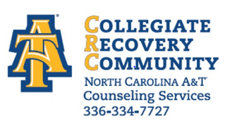

The information you provide below will be discussed and taken into consideration with regard to your candidacy for admittance into the A & T Collegiate Recovery Community. The information will only be used for the stated purpose; this information is not part of the University Admissions process nor does it preclude your ability to apply for campus housing if you are not admitted into the Recovery Community.

Personal Information
Full Name:
 | Last | First | M.I.

Current Mailing Address:
 | Street Address | Apartment/Unit #

 | City | State | ZIP Code

Permanent Phone: |  | Cell Phone:

Email
Age:

Birth Date: |  | Sober Date:

Are you applying to be ally?

Yes
No

Emergency Contact Information
Full Name:
 | Last | First | M.I.

Address:
 | Street Address | Apartment/Unit #

 | City | State | ZIP Code

Primary Phone: |  | Alternate Phone:
Relationship:

How would you describe your present source of support?

Education Information
Are you currently enrolled in N C A&T State University? Yes No
If yes, please indicate: Full time Part Time |  | Employee ID: |  |  | Department:

Major: |  |  | Classification:

Have you attended A& T State University before? □ Yes □ No If Yes last attended: □ Fall □ Spring □ Summer

Year: ____________

Educational Plans

Desired major/academic interests: Hobbies/sports/outside interests:

Will you be requesting any accommodations via Student Disability Services? _____ Yes _____ No

Recovery Needs

1. What are your primary reasons to continue in a life of recovery?

2. Do you have a history of relapse? If yes, please explain.

3. What do you do in your life to protect your recovery?

4. What challenges will you face while striving to be successful in college AND maintaining a healthy recovery program?

Chemical Dependency History

Do you believe you are chemically dependent? _____ Yes _____ No Other ______________

Drug(s) of Choice ______________________________________________________________________

Have you ever attended substance abuse treatment? _______ Yes _____ No

Have you ever lived in sober house? _______Yes_______No

Do you have concerns with other addictions such as gambling, sex, exercise, shopping, money issues, issues with food, etc.?

Tobacco: _____ Non-smoker _____ Smoker _____ Smokeless Tobacco Products

Thinking about quitting? _____ Yes _____ No

Mental Health History or Concerns
Have you been diagnosed with a mental health disorder? If yes, please explain.

Eating Disorders: _____ Yes _____ No Self-injurious behaviors: _____ Yes _____ No

Legal Issues / Concerns

LEGAL ISSUES/CONCERNS Is participation in the Collegiate Recovery Community recommended to you by the courts or are you under any pressure from lawyers or parents to attend? _____ Yes _____ No

Do you have any legal concerns? If so, please explain.

If a release of information is necessary for anyone including: an attorney, probation, or parole officer, please include their name and phone number here:

Name: ____________________________________ Phone #: _______________________________

Would you be interested in Serenity Place housing? _____ Yes _____ No

My signature below indicates that the information I have provided in this application is true and accurate to the best of my knowledge. Any misrepresentation may lead to non-admittance or dismissal from the Collegiate Recovery Community.

_______________________________________________________Date_______________
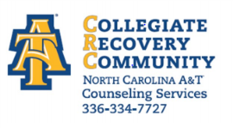
Prospective Participant Signature

